APSC 496

Critical Function Prototype Report

Praxim - Surgical Robot

Submitted on: 30-NOV-2009

Submitted by: Nicholas Adams

Davy Chiu

Ibrahim Gadala

David Mountford

Erica Wodzak

# 1.0 Introduction

# 2.0 Critical Function

The critical function evaluated is this document is the “cutting tool moves” function identified in the functional decomposition. The ability for the user to move the cutting tool in 3D space is essential to the ultimate project goal of generating a 3D hard surface and interfaces with other functions that have significant impact on the design – these include the mechanism used to implement and move the hard surface, how the device is secured to the knee and the types of shapes that can be created. This function also has a direct impact on many of the design requirements. The mechanism selected will set limitations on the size and weight of the device due to the type of joints used in the design, as well as motor speed and accuracy requirements and how the user interacts with the device. As a result, it is important that these effects are considered early, before the interfacing functions are developed further.

From the analysis completed in this report we plan to finalize the mechanism that allows the cutting tool to move in 3D space and assess the impact of link lengths on the envelope of the device.

# 3.0 Description of Prototype

The prototype developed to assess the critical function is based on a previous prototype used to evaluate the feasibility of the entire concept in 2009. This existing prototype implements a three link mechanism consisting of two rotational joints and one linear joint. The drawback with this link arrangement is the size and weight of the linear joint, and as a result linear joints will not be considered for this mechanism.

The portion of the existing prototype used for the critical function prototype is shown in . The motor and encoders were removed from linkage 1 and linkage 2 leaving only the mechanism developed by Nikolai Hungr. The ideal lengths of linkage 1 and linkage 2 are 5 cm and 4.5 cm respectively, based on Hungr’s analysis. The critical function prototype developed, however, uses link lengths of 5.5 cm and 6.0 cm. This combination of link lengths will be used to evaluate the potential operating enveloped of the device, but further analysis is necessary before these lengths are finalized.

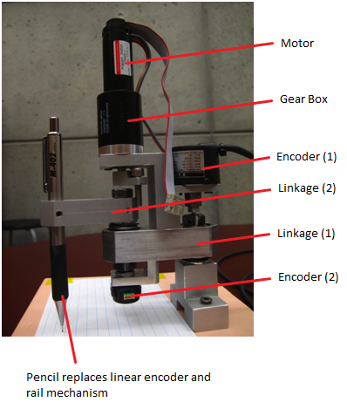

Figure – Dynamic Physical Constraint mechanism used in existing prototype

## Prototype 1

Prototype 1 (PT1) consists of three rotational joints at positions 1, 2 and 4. Bearings have been used at joints 1 and 2 while link 4 is allowed to rotate by a set screw held in place by a setscrew. Link 3 is a kept stationary by a setscrew and is not allowed to rotate. The link 3 has been designed to be repositioned depending on the experimental requirements. Link 4 has also been designed to vary in length from 3 cm to 6 cm in increments of 1 cm, but will be set at 6 cm for Prototype two. Figure 2 provides an overview the Prototype 1 mechanism. The figure highlights the relationship between Link 3 and Link 2 and the position of Link 4 and the cutting tool because they cannot rotate with respect to each other.

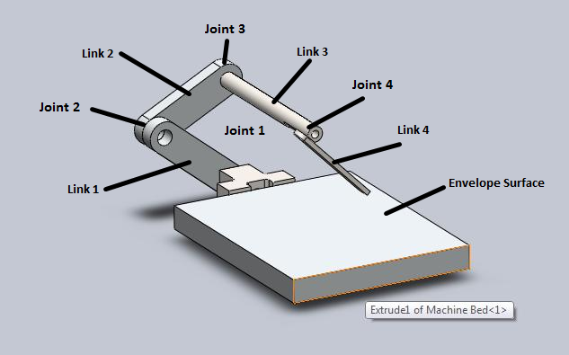

Figure – Model of prototype 1

Table – Prototype 1 link lengths

|  |  |
| --- | --- |
| **Link** | **Length [cm]** |
| Link 1 | 5.5 |
| Link 2 | 6.0 |
| Link 3 | Set to 10 |
| Link 4 | 6.0 |

## Prototype 2

Prototype 2 (PT2) consists of four rotational joints at positions 1, 2, 3 and 4. Bearings have been used at joints 1 and 2 while link 4 is allowed to rotate by a set screw held in place by a setscrew. Link 3 is a kept allowed to rotate by loosening the setscrew but a stopper is placed at the end to stop translation. Link 4 will be set at 6 cm for Prototype 2. In model of Prototype 2 – shown in Figure 3 – Link 3 can rotate with respect to Link 2 and Link 4 can always be oriented towards the envelope surface as a result.

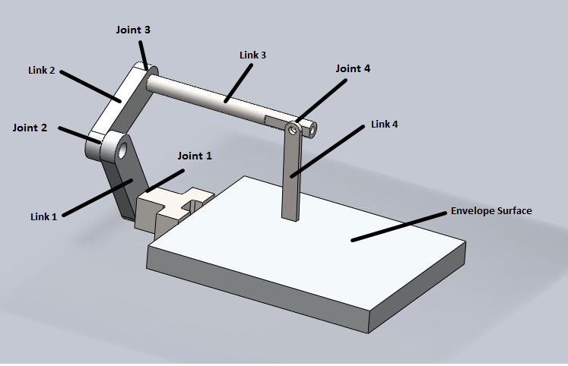

Figure – Model of Prototype 2

Table – Prototype 2 link lengths

|  |  |
| --- | --- |
| **Link** | **Length [cm]** |
| Link 1 | 5.5 |
| Link 2 | 6.0 |
| Link 3 | Set to 10 |
| Link 4 | 6.0 |

# 4.0 Experimental Method

The following experiment was formulated to examine two aspects of both prototypes being considered. The first aspect to be examined was the size of the machining envelope to see if it would be sufficient. The second aspect was to determine if there were any locations that the tool would be unable to reach.

**Testing Protocol**

The purpose of the testing protocol is to see if the desired range of motion is achieved with the rotation-rotation-rotation joint configuration design within the specified requirements. In order to complete Unicompartmental Knee Replacement Surgery the tool must have access to both femoral lobes. This can be achieved in two ways; (1) a linkage mechanism with a range of approximately 16 cm - equivalent to the entire knee - or (2) a linkage mechanism in which linkage 3 is adjustable to allow operation on individual lobes using the same mounting position.

**Range of Workable Area**

This test is to determine the feasibility of two design types; (PT1) four link mechanism with rotational joints at positions 1, 2 and 4 and (PT2) four link mechanism with rotational joints and positions 1, 2, 3 and 4. Steps will be taken to access the effectiveness of both designs with respect to the entire knee from one position design and the individual lobes design discussed above.

Assumptions/Requirements:

1. Device is rigidly fixed to femur (no play in the bone mount)
2. Link 2 will never be perpendicular to the generated surface
3. Link 4 has a maximum angle of 45 degrees from the vertical position
4. Link 4 cannot come into contact with the support structure
5. Entire knee envelope has a radius of 8cm
6. Single lobe envelope must be 16cm by 8cm
7. Lateral deflection cannot occur
8. Linkages cannot transfer between right and left orientation
9. Link 4 length is 6cm

Method:

1. Setup up mechanism in MODE 1
2. Position mechanism in right orientation
3. Set reference point to the position where link 4 is perpendicular to surface and in line with the axis of the mechanism
4. Position tool (end of link 4) along the surface of the support structure at a edge of the envelope – on the verge of lateral deflection
5. Moving the tool along the surface and maintaining near lateral deflection position, map out the envelope of the current setup moving link 4 from +45 degree to -45 degree position
6. Maintain -45 degree position keeping tool on the surface, map out the envelope generated until link 1 is perpendicular to the surface
7. Moving the tool along the surface and maintaining link 1 perpendicular to surface position, map out the envelope of the current setup moving link 4 from -45 degree to +45 degree position
8. Maintain +45 degree position keeping tool on the surface, map out the envelope generated until mechanism reaches the lateral deflection position
9. Repeat for all steps for MODE 2

**MATLAB Simulation**

In order to have a more visual representation of the workable area, a Matlab script was written to plot the possible motion of both concepts. The script generates points at various combinations of link angles at each of the joints and maps these points out to create an envelope volume. The script, however does not take later deflection into account and no final conclusions can be drawn from the generated envelope. Later in the design process the script can be adapted to optimize link lengths and find the optimal range of angular deflection for each link.

# 5.0 Analysis of Results

After completing a physical prototype of the robot’s new linkage system, the critical function was preliminarily examined with a series of basic tests. The main feature we tested for is the range of workable area the linkage allows for.

Prototype 1:

At first, our shaft link (3rd link from the bone mount) simply acted as an offset for the system, as it was rigidly fixed against movement with a set screw in its joint with the second link. All three other links were allowed to rotate in their respective planes. Although this set-up provides an easier task for hard-constraint calculations and control, since you need 1 less encoder and a less intensive mathematical calculation, the workable range provided is greatly lacking. Effectively, with the link sizes of the prototype we tested (15 cm shaft and 6 cm tool link), the area was a triangle with a height of merely 2 cm and a base length of about 3 cm. {reference to picture with the triangles}. Errors in this analysis include possible slippage in the set screw fixation, flexibility in the link structure (final prototype will be designed more for sturdiness and rigidity), and the inconsideration of the tool bit orientation and size. For the latter, it was assumed that the point of contact of the final, 4th link with the surface will provide sufficient tool penetration for cutting, and that the tool was oriented at an angle to promote better machining conditions. Thus, it could be stated that the resulting limitation of this analysis is the fact that not everywhere the final link on the prototype touched the work surface actually results in bone cutting conditions.

Prototype 2:

We decided to test whether the range from the previous set-up would be improved if the 3rd shaft link was allowed to rotate about its axis. The change was immediate and obvious. The rotation of the shaft link effectively allowed the projection of its rotation angle to be added to the range of the workable area, thus greatly increasing it. With the same link sizes used for the first testing set-up, this added degree-of-freedom to the third link allowed us to work on a rectangle with side lengths of 9 cm and 5 cm {reference to picture with the triangles}. That being said though, implementing this extra DOF requires an additional encoder and a more intensive mathematical and computing process for hard surface control. Inherently, this analysis has less possible errors than the analysis of prototype 1, since slippage of the shaft link is allowed, and the tool is allowed to be oriented at many more angles that with the shaft secured in place. However, errors in this analysis still arise from linkage system flexibility and possible slippage of the shaft link *axially*, which would not occur in a real-life scenario. Thus, the main assumption for the analysis of prototype 2 is that, while taking work area measurements, the shaft did not slip axially as to provide a larger final work area. This means that a major limitation of this analysis is that the work area measured is the upper value of the range possible, since the shaft could not have possibly stayed fixed at the joint, yet we assume it did so we make a obtain a less conservative result. In essence, the undisputed result of this analysis is that prototype 2 has a significantly larger work area than prototype 1.

**MATLAB Simulation Results**

The MATLAB simulation has been used to verify the results generated from PT1 and PT2 and provide an estimate of each prototypes envelope.

Prototype 1:

Figure 4shows the enveloped generated for PT1 using the link lengths from Table 1. In the MATLAB script Link 4 has been offset by 30 degrees resulting in the orientation shown in Figure 4. In the x-y plane, horizontal to the envelope surface , PT1 has a range of approximately 10 cm by 15 cm. These results are somewhat deceiving as there are many locations within this volume that cannot be reached and the cutting tool is constrained to specific paths when trying to move in a single plane. This restricted motion can be seen by the significant holes in the generated operation space. Figure 4 also suggests that the vertical envelope is reduced to the point that the user will not have freedom of motion away from the surface in some areas.

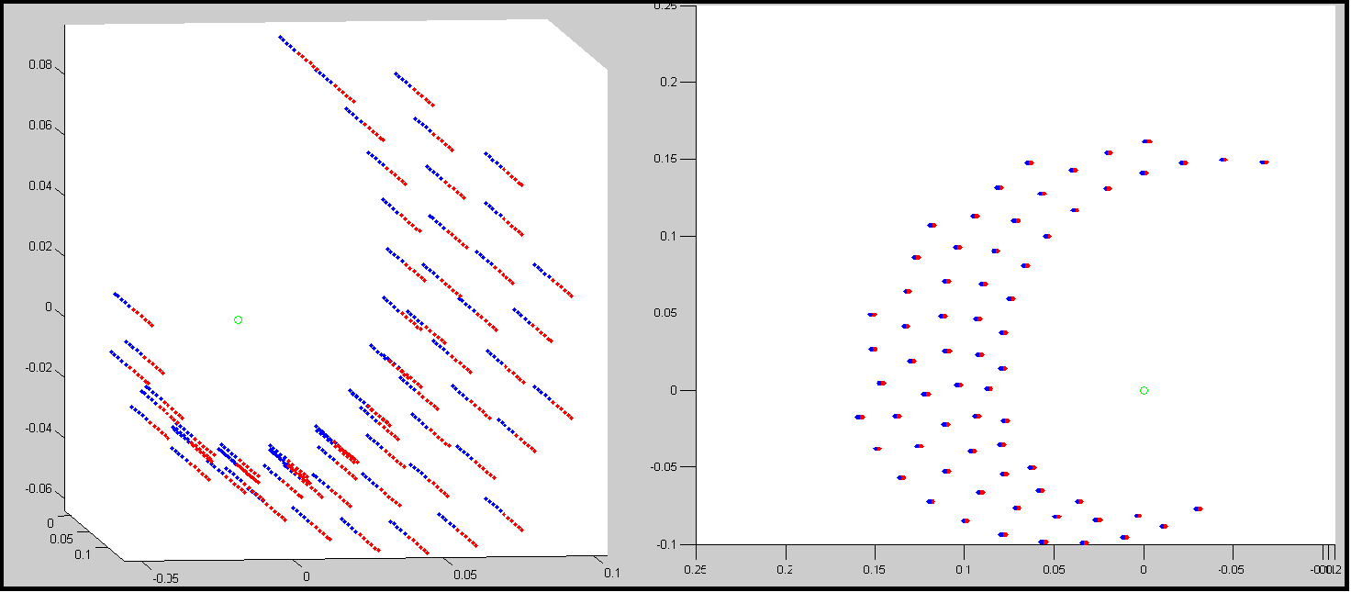

Figure – Prototype 1 MATLAB range of motion simulation

Prototype 2:

The analysis of PT2 has been conducted using the link lengths described in and the generated spatial plot is shown in . The x-y plane enveloped created by PT2 is slightly larger than PT1 at approximately 18 cm by 10 cm. More significantly the envelope plot of PT2 does not have the same vertical restrictions. The result indicates that PT2 in its current setup can have a vertical range of approximately 7cm while maintain a 15 cm by 10 cm envelope. The user will have far more freedom away from the imposed constraint and a greater variety of hard constraints can be imposed as a result.

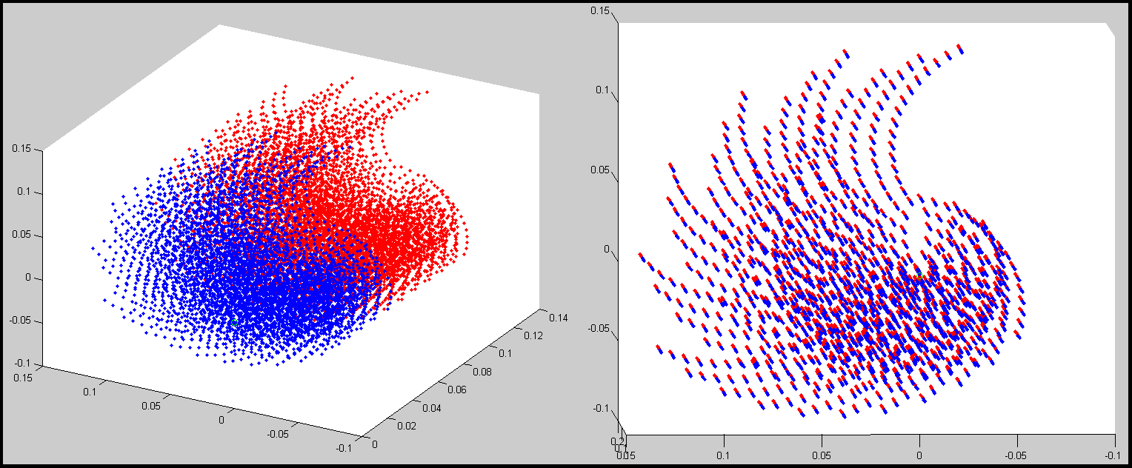

Figure – Prototype 2 MATLAB range of motion simulation

Table – Summary of critical function prototype analysis

|  |  |  |
| --- | --- | --- |
| **Test** | **Prototype 1** | **Prototype 2** |
| Physical test envelope in x [cm] |  |  |
| Physical test envelope in y [cm] |  |  |
| MATLAB max x envelope [cm] | 10 | 10 |
| MATLAB max y envelope [cm] | 15 | 18 |
| MATLAB usable z envelope [cm] | 1 | 7 |

# 6.0 Future Steps and Updated Timeline

A better understanding of the geometry and the installation of unicompartmental knee implants will be required in order to determine if the device's workable area is sufficient to do both implants with one setup, or if the length of link 3 should be adjustable to allow setup for individual implants.

In order to finalize the design of this concept we need to develop the concepts of the functions that interact with this function further. Developing these concepts will aid in finalizing specifics of the critical functions.

A new timeline has been developed to better reflect the our current status and goals for the next month, as well as a rough timeline estimate for tasks further in the future. This updated timeline can be found in Appendix B.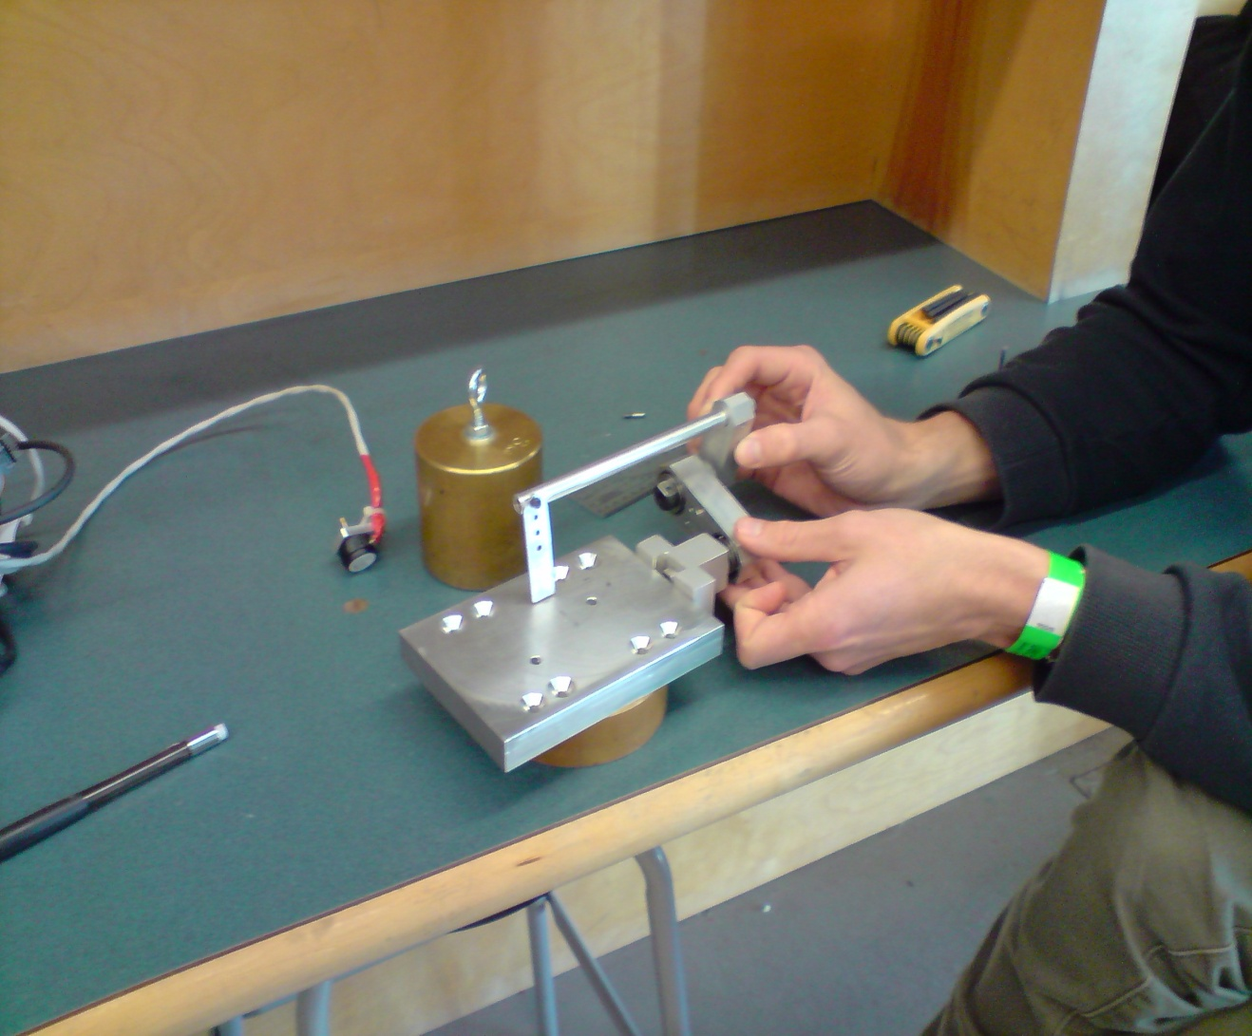

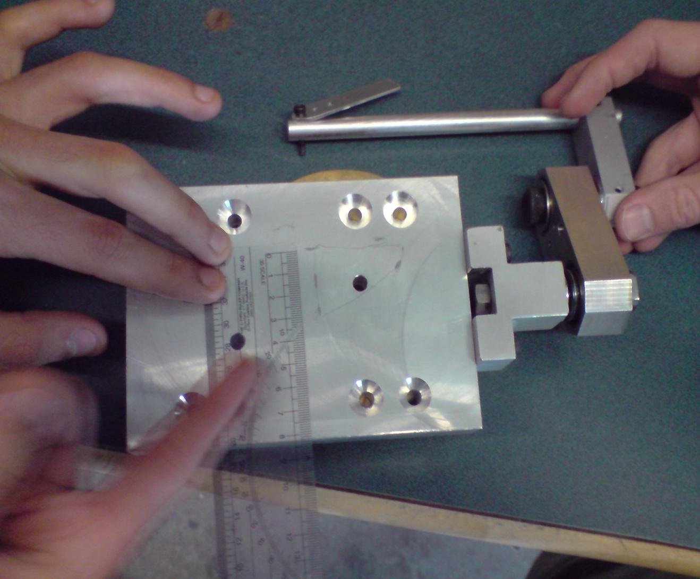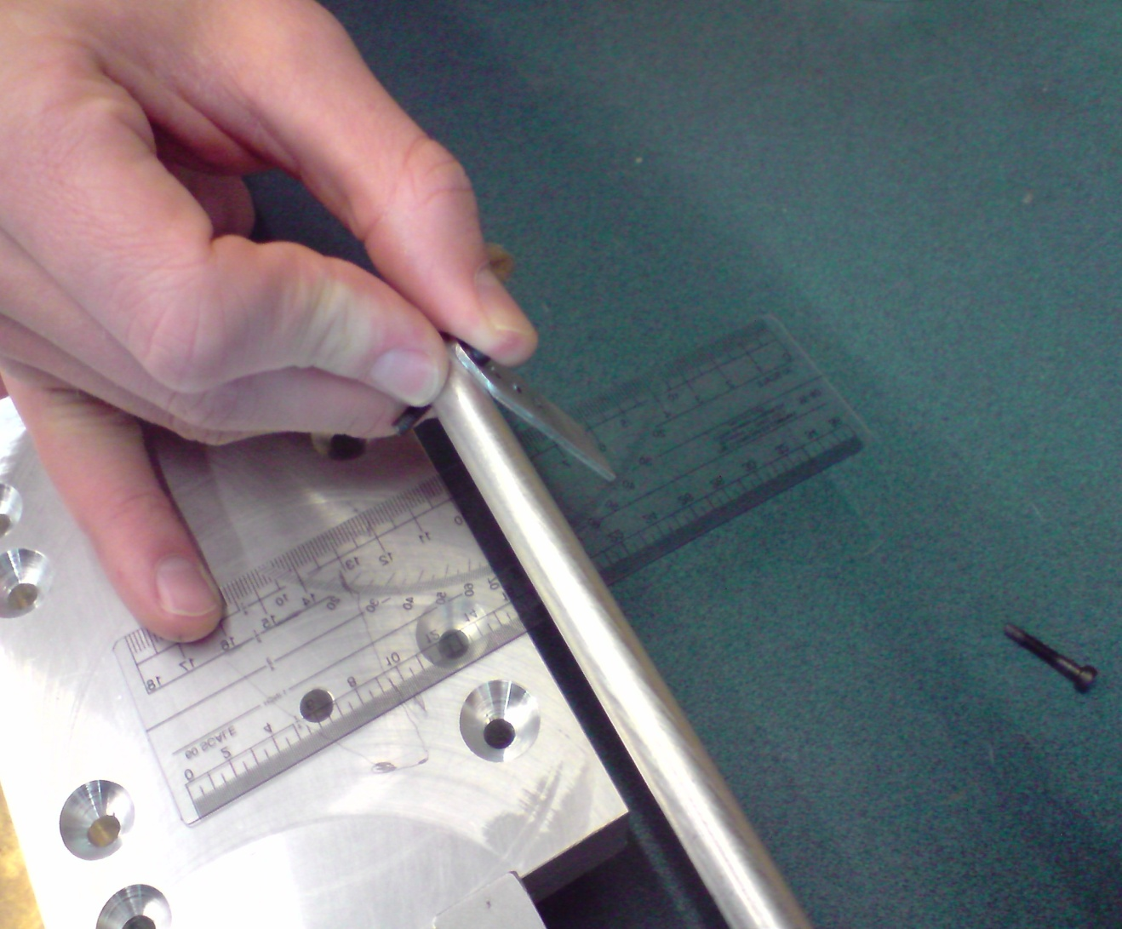

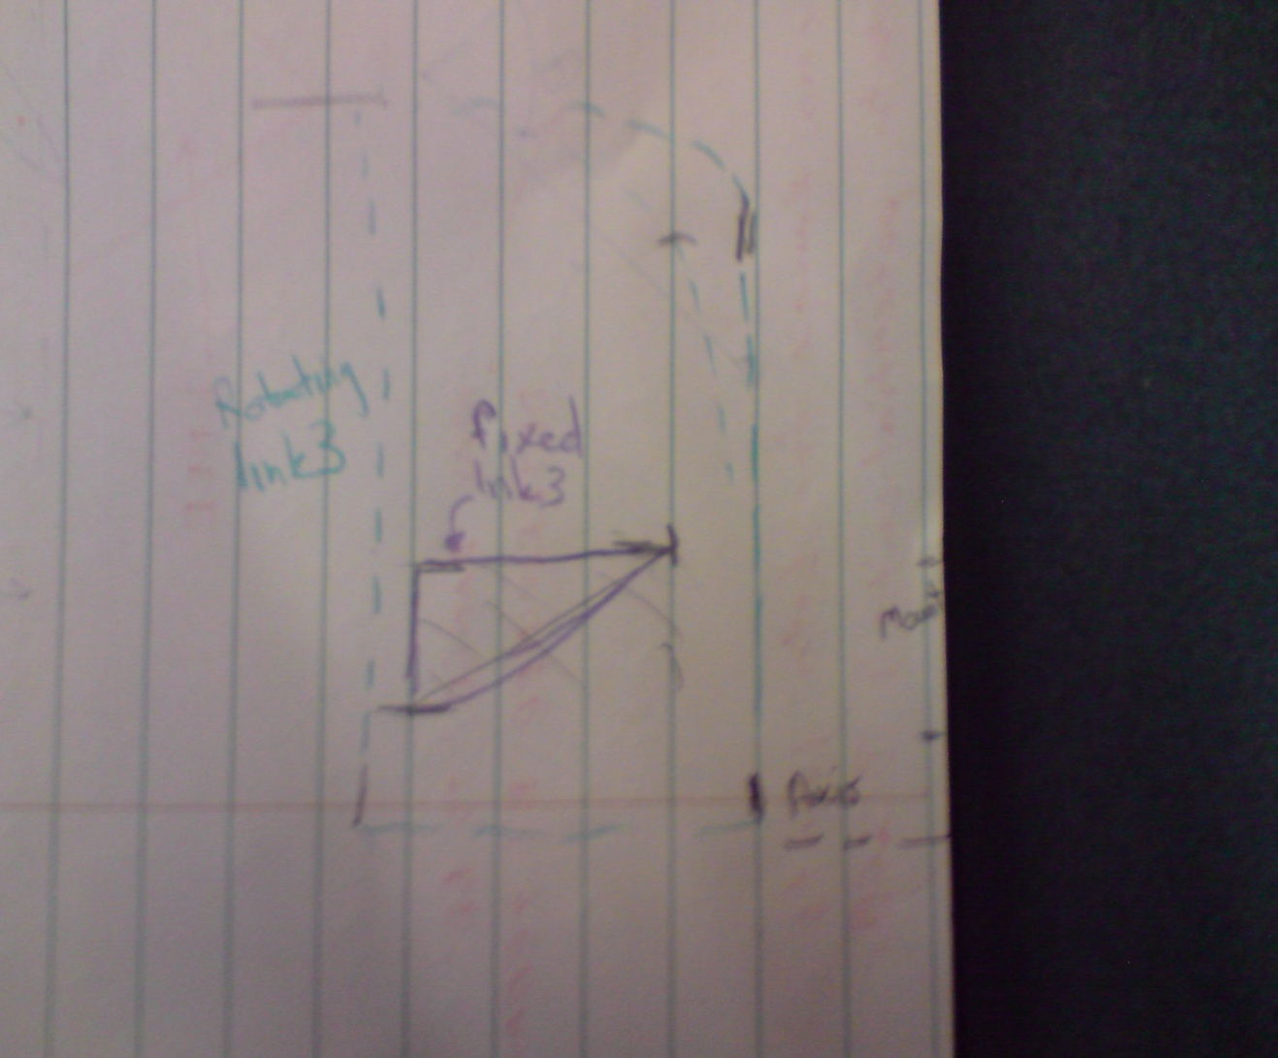

# 7.0 Conclusion